**55-407292: Fundamentals of Programming for Computer Science**

**Final Coursework Task:** Follow Me Brain Training Application

**Due in:** Thursday 19th March 2020 at 3pm (via Blackboard)

**Marks Available:** 100 (30% of the module assessment)

In this task you will demonstrate your knowledge, understanding and ability to identify appropriate programming concepts and practices in C/C++. This is an individual piece of work and in-module retrieval is not available for this assessment.

**Introduction**

You will create a Follow Me Brain Training application in C/C++ using the EasyGraphics windowing library. An illustration of the application is given in Figure 1 and an example is provided on the module Blackboard site.

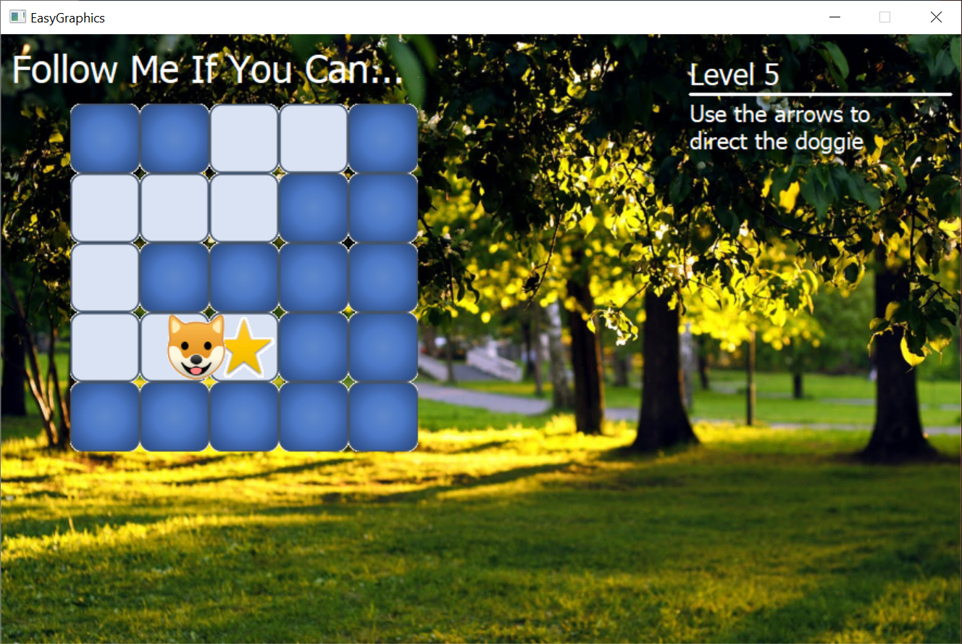

*Figure 1: Illustration of the Follow Me application*

It isn’t necessary to visually replicate the example exactly; in fact, it would be nice to see your creative individuality come out during the creation of the program. The following fundamental principles of the application must be included though:

* The size of grid is based on the level using the following rules:
  + For levels 1 to 4 inclusive, the grid is a 4x4
  + For levels 5 to 9 inclusive, the grid is a 5x5
  + For levels 10 and higher, the grid is a 6x6
* The number of steps in the path to follow is determined by the following rule:
  + 3+level number
* The path to follow is randomly generated and doesn’t need to use unique grid cells only (i.e. it can go over the same cell more than once). However, the path cannot immediately backtrack onto itself (i.e. return to a cell is was immediately prior to the cell it is currently in)
* When following the path, the avatar continues in the same direction unless a user presses a key to change it at the next junction
  + The user can press a direction key while the avatar is travelling towards a new cell and it will change direction only upon reaching the centre (see example)
* Cells that have been visited are displayed in a different colour to those unvisited per level
* High score table that is loaded and saved to a file (score = last successfully complete level)
* A “cheat” key press that toggles the visibility of the route as a red line (‘C’ in the provided example)

The aim of this task is to demonstrate your knowledge, understanding and ability to identify and apply appropriate programming techniques taught in this module and thus the code is more important than a polished application. You will be grading on your demonstration of key principles and concepts (competencies) in the creation of this application as outlined in the grading section; please read this carefully and ensure you have covered all competencies in the creation of the Follow Me application. Even if you don’t get a fully working application, you will still get credit for what you have achieved.

**Code Development**

There is no single correct solution and you will have to make many decisions about the implementation but do so logically and thoughtfully.

**Hints**

* Use methods/functions to help segment your code into manageable and meaningful modules that can aid reuse and readability
* There is no single right solution, but some code is better than others… think about what you are doing, what you want to achieve and implement it in a sensible, robust and efficient manner
* Provide comments to aid comprehension of your code
* Evolve your code and regularly test what you have written; when I put together applications, I didn’t sit down and write it in one go and expect it to run… I build the application in small stages, progressively adding in functionality and testing and debugging as I go (yes, everyone needs to test and debug code they write no matter how long they have been coding for so get practiced at doing so – I certainly didn’t sit down and knock out the example application in one go)

**Grading Guidelines**

Marks will be awarded as illustrated below:

|  |  |
| --- | --- |
| **Competency being assessed** | **Percentage Available** |
| Logical structuring of code that minimises repetition and uses sensible functions | 10% |
| Appropriate use of variables and constants (don’t have everything declared “globally” within the class and use local variables where appropriate) | 15% |
| Use of control structures (selection: if, if-else, switch and repetition: for, do/while) | 35% |
| Use of functions (returning results, passing parameters by value and by reference and passing an array as a parameter) | 15% |
| Input/Ouput (load and save) | 10% |
| Use of structures and vectors | 10% |
| Consistent and sensible layout and formatting, structure of code and naming using appropriate comments | 5% |

The University common grading descriptor will be used to determine marks within each area (provided at the end of this document). The marking scheme embeds the concept of extended work by rewarding only the highest marks to those who demonstrate evidence of independent investigation, learning, critical thought and problem analysis (via good code solutions).

**Submission Process**

Your assignment should be submitted electronically through the module Blackboard site as a single ZIP file that contains your entire project and source code (minus build and intellisence files and folders), and a ReadMe.txt file that gives brief instructions about using your application. Your last on-time attempt will be viewed and graded (as per university regulations).

The source code must be in the form of a Visual Studio 2017 project within the compressed ZIP file and contain all files that allow the project to be opened, built and run on a campus computer (this includes any assets you may have used, which must use relative pathing in the code - ***do not use absolute paths as I will not have the same drive structure as you outside the project folder***). Make sure that you upload the correct files by checking once you have submitted - mistakes discovered after the deadline cannot be corrected; it is your responsibility to ensure that you submit the correct files by the deadline. You may be asked to provide a walkthrough of your code during which you will need to discuss all aspects of the work you submitted with your grade being subject to a successful walkthrough and discussions of your work.

**Remember to include all source code and check your submission once uploaded.**

The submission deadline is given at the top of this document.

**Learning Outcomes**

This task assesses the following learning outcomes from the module descriptor

* Describe, recognise and deploy essential features of a mainstream programming language (such as C/C++) and use them to implement solutions to a variety of programming problems, selecting appropriate control constructs and data structures
* Select and apply appropriate software tools and program testing techniques on small programs

# Level 4 - Generic grade descriptor: relationship of degree classification to percentage mark ranges and categorical grades (CG)

|  |  |  |  |
| --- | --- | --- | --- |
| **Class** | **Mark range** | **CG%** | **General Characteristics** |
| FIRST  (Excellent) | 93 – 100 | 96 | Exceptional knowledge and understanding of the subject and its underlying concepts; critical evaluation/synthesis/analysis and of reading/ research; evidence of breadth and depth of reading/research to inform development of work; exceptional demonstration of relevant skills; excellent communication; performance in some, if not all, areas deemed beyond expectation of the level. |
| 85 – 92 | 89 |
| 78 – 84 | 81 | Excellent knowledge of the subject **as the student is typically able to go beyond what has been taught (particularly for a high 1st)**; evidence of breadth of reading/research to inform development of work; excellent demonstration of relevant skills; demonstrates strong communication skills. |
| 70 – 77 | 74 |
| UPPER SECOND  (Very good) | 67 – 69 | 68 | As below but very good work characterised by evidence of wider understanding of the subject as the student **is typically able to relate facts/concepts together with some ability to apply to known/taught contexts**; identification and selection of material to inform development of work; very good demonstration of relevant skills; demonstrates good communication skills. |
| 64 -66 | 65 |
| 60 – 63 | 62 |
| LOWER SECOND  (Good) | 57 – 59 | 58 | A good breadth of knowledge and understanding of the taught content although **balanced towards the descriptive rather than analytical**; uses set material to inform development of work; addresses all aspects of the given brief; good demonstration of relevant taught skills, though may be limited in range; communication shows clarity but structure may lack coherence. |
| 54 – 56 | 55 |
| 50 – 53 | 52 |
| THIRD  (Sufficient) | 47 – 49 | 48 | **Knowledge and understanding is sufficient to deal with terminology, basic facts and concepts** but fails to make meaningful synthesis; relies on set material to inform development of work; generally addresses most of the requirements of the given brief; adequate demonstration of relevant skills over a limited range; communication/presentation is generally competent but with some weaknesses. |
| 44 – 46 | 45 |
| 40 – 43 | 42 |
| FAIL  (Insufficient) | 30 – 39 | 35 | Insufficient knowledge and understanding of the subject and its underlying concepts; some ability to evaluate given reading/research however work is more generally descriptive; naively follows or may ignore set material in development of work; given brief may be only tangentially addressed or may ignore key aspects of the brief; demonstration of relevant skills over a reduced range; communication shows limited clarity, poor presentation, structure may not be coherent. |
| 20 – 29 | 25 |
| 10 – 19 | 15 | Highly insufficient or no evidence of knowledge or understanding of the subject; **understanding of taught concepts is typically at the word level with facts being reproduced in a disjointed or decontextualised manner**; ignores set material in development of work; fails to address most or all of the requirements of the brief; fails to demonstrate relevant skills; lacks basic communication skills. |
| 1-9 | 5 |
| ZERO | 0 | 0 | Work of no merit OR absent, work not submitted, penalty in some misconduct cases. |